January 2018
Year Seven Full Report
Dear Parents / Carers,

Your child’s Full Report has been issued today. If we have your email address, then the report will also be available on our data system: Go 4 Schools.

If you have not accessed Go 4 Schools before, you will need to follow these instructions:
• Go to www.go4schools.com
• Once there, click on the ‘Parents’ tab in the top right hand corner.
• Enter your email address into the First Time User section.
• You will be sent a password and instructions about how to log on to the Go 4 Schools site
• Once there, you will be able to access your child’s report.

You can also access Go 4 Schools by following the link from the Limehurst Academy website: www.limehurst.org.uk

If you would like subsequent reports to be available to you on the Go 4 Schools site, please complete the slip at the bottom of this letter.

On the reverse of this letter there is an explanation of the information contained in the report.

There will be an opportunity for you discuss your child’s progress further, later on in the academic year at the Year Seven Parents’ Evening, which will be held on 30th April.

If you have any concerns about your child’s progress, please contact their form teacher.

Yours sincerely,

Mrs V Beeby
Assistant Headteacher
………………………………………………………………………………………………………………………………………………………………………
REPLY SLIP PLEASE RETURN TO MRS F REED, LIMEHURST ACADEMY

Name of Child: ……………………………………………………………

Form: ………………

I would like to be able to access information about my child’s progress, using the Go 4 Schools website.

My email address(es) is/ are: …………………………………………………………………………………………………………………..

………………………………………………………………………………………………………………………………………………………………………………...
Signed by the person with legal responsibility for the young person.

Minimum Outcome Grades (MOG)
These are the grades that other students with similar Key Stage Two results to your child achieve at the end of KS4 (when students take GCSEs).
These don’t tend to change much throughout your child’s time at Limehurst. Instead, the standard of work required to achieve the grade becomes harder as a child progresses through each year.
A MOG is the minimum grade we think your child should achieve at GCSE.
Predicted Outcome Grades (POG)
These are the grades your child’s teachers think that your child are most likely to achieve at the end of Year 11, based on the rate of progress they are currently making.
If the MOG and POG match, then your child is making good progress.
If the POG is higher than the MOG then your child is making excellent progress.
If the POG is lower than then MOG then your child is making less progress than we would expect.
Fine Grading
We divide each grade into three, to give an idea about how confident we are that your child will achieve that grade.
For example:
A student with a Grade 4- : your child’s teacher thinks that your child should achieve a Grade 4, but they are close to missing out on this grade.
A student with a Grade 4: your child’s teacher is confident that this grade should be achieved if your child continues to make their current rate of progress.
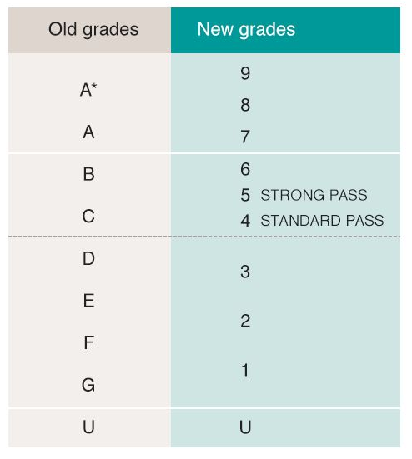
A student with Grade 4+ : your child’s teacher is confident that this grade should be achieved if your child continues to make their current rate of progress, but that they should be aiming to achieve a grade higher, in this case, Grade 5.

This diagram shows how the number grades relate to the letter grades that used to be used at GCSE.

Your child’s report also contains information on their attitude to learning and homework in each subject area, plus summaries of positive and negative behaviour points and attendance throughout the year to date.

